Satish Chandra Memorial School
Summer Holiday Homework
Class- VI Subject – English
- HOTS ( To be answered in 100-120 words)
  - How does a school play a parental role in the brought up of a child?
  - Parents or Guardians protects us from all harms and give us a safe life . Elucidate.
  - The wonders of sleep are many. Elaborate.
  - Compare and contrast a life with and without words .
  - India is famous for Classical Music since ages . How?

- 1.Write a letter to your friend sharing about your parameters of improvement during this summer break.
2. Write a message to your mom telling that you will be at your friend’s house in your locality for two hours . When your friend came to pick you, your mother had gone to the nearby temple. So, you had to leave ,dropping a message because you all were going to complete the art integrated project given by your school.
3. Write a composition on the following picture.

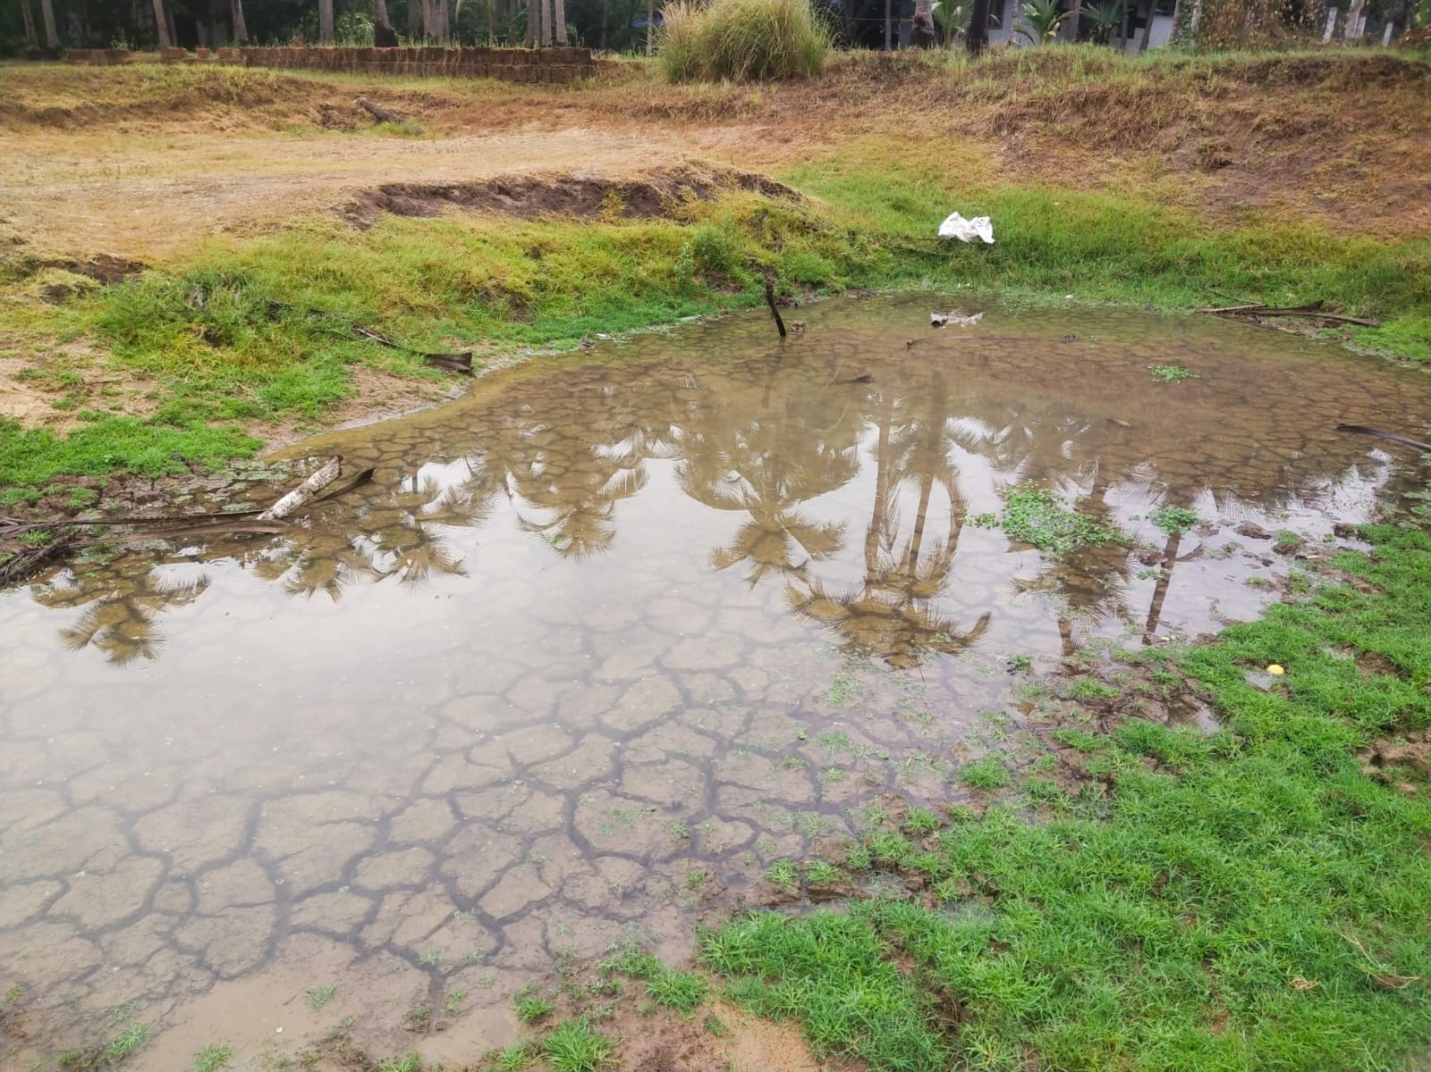
III) Mixed Questions
- State the function based sentences as Assertive , Imperative, Interrogative or Exclamatory .
1.The sun rises in the east.
2.Did you finish your homework?
3. Please pass the salt.
- What a beautiful sunset!
- Close the door.
B. State the sentences based on structure as simple, or compound or complex or compound- complex:
1. She runs every morning.
  - She runs every morning, and she swims every evening.
  - While I was reading, the phone rang.
  - Although it was raining, I decided to go for a walk, but I took an umbrella just in case.
  - I went to the store and bought some milk.
C .Fill in the blanks with appropriate conjunction words:
1. She wants to go to the party, ____ she has a lot of homework to do.
2. He is tall _____ he is strong.
3. I will eat ice cream, ______ I will have cake for dessert.
4. She can either go shopping _____ stay at home and read a book.
5. The concert was canceled ______ we decided to go to the movies instead.
6. He studied hard _____ he wanted to get good grades.
7. Sarah is smart _______ she is lazy.
8. I am tired ________ I have to finish this assignment.
9. He didn't like the movie ___ it had good reviews.
10. She ran quickly _____ he walked slowly.
D. State the starred parts of the given sentences as phrase or clause:

1. **The cat** sat on the mat.
- Phrase / Clause

2. **After the rain** stopped, we went for a walk.
- Phrase / Clause

3. He likes to read **science fiction novels**.
- Phrase / Clause

4. **When I was younger**, I used to play soccer every day.
- Phrase / Clause

5. **Running through the forest**, she felt a sense of freedom.
- Phrase / Clause

6. I need to buy **a new laptop**.
- Phrase / Clause

7. **Although she was tired**, she went to the gym.
- Phrase / Clause

8. **In the morning**, we'll go for a hike.
- Phrase / Clause

9. **Because he forgot his keys**, he couldn't enter the house.
- Phrase / Clause

10. **Under the bridge**, there is a stream.
- Phrase / Clause

